

Core Functionality: A system will sell cars

Team Members

Charlotte

Jack

Joe

Daniel

System Overview

The program system will be produced to be used by staff in a car dealership shop, to sell cars to customers. The staff will have access to a web based front end, allowing them to browse and filter available cars in stock for customers. They will be able to filter depending on price and features. There will be options for staff to place cars into a shopping cart and create an order. They will be able to choose modifications to add to the shopping cart.

First, upon creation of the order, the customers will have to create an account that will store payment (banking) and personal details. Additionally, there will also be facilities that will allow them to modify, review and cancel the order while its in the shopping basket, and before it has been fully processed. At checkout, the customers will be given different financial options by the staff member which they are reading from the database. This will be applied to the price, and options will allow them to spread the cost over a number of months.

Once a customer has submitted an order, it will be accessible by staff in the back end of the system to execute and review the order. The back-end system will also handle stock and running various reports on the data stored and manage staff and customer data. This part will not be accessible to the public.

Allocated Components

* Jack – Staff Accounts:

The staff records for order reference on order and finance

Adding, removing, editing, listing and filtering staff members.

* Charlotte - Customer records:

Customer info in database, personal data and banking dank

Adding, removing, editing, listing and filtering customer records.

Unique reference number assigned to each customer

* Joe – Car records and stock:

Allows for maintenance of stock of variety of cars, add, edit, delete

Car table so the car brand and attributes in stock to buy

Adding, removing, editing, listing and filtering car records and stock.

* Dan – Order processing:

Allowing frontend staff to input orders for customer, backend staff process that order

Allow for customers input, staff to process order, order to be dispatched. Adding, removing, editing and listing order and shopping basket.

ERD Diagram

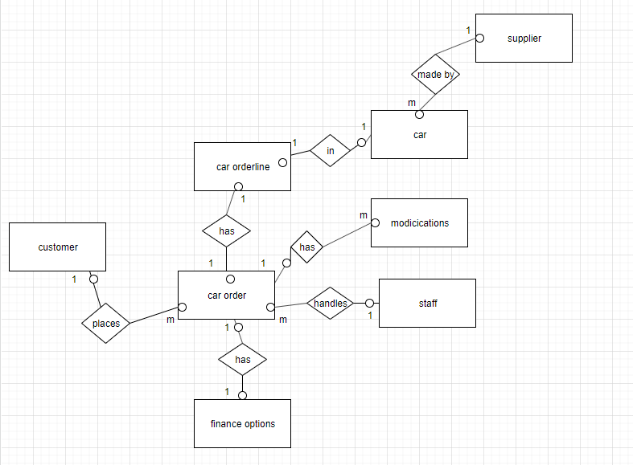

Individual Specification

Allocated component = Customer Records system

Developer = Charlotte Lincoln

Overview:

A customer will visit their local car dealership shop. They will then be able to look around at cars. When assigned a member of staff they will be able to look through all the cars in stock to buy, through the staff’s web applications on their tablet or computer. The staff and customer will be able to browse through the cars and modifications available

Customers will then have the option to create an account and add themselves to the system. On the creation of an account they will be asked to make a username and password to keep their information secure. This will also allow them to keep track of their order and payments.

They will also be asked to submit contact details which will include emails and address. This is so the company can keep the customer updated on their order and payments and contact them if any issues arise. A customer will be able to edit and update their details after an account is created. Additionally, if there is no pending or outstanding order or finances, they will be able to delete their account.

Payment details will also be requested for payment of product. Additionally, upon creation of order customers will be able chose a financial option for their payment.

If a customer has been a customer for longer than a year they will be available for loyalty discount that will be 10% off total price of the order.

On the system back end, staff of the company will have the option to handle the management of the data for all customers. This will include function such as add, edit, delete on the company or customers behalf. They may also run reports and list all customers data for company purposes.

Customer Table

tblCustomerRecords

CustomerID Int primary Key

FullName Text

Email Text

MobileNumber Int

Address Text

DateAdded Date

LoyaltyDiscount Boolean